Polygon–Circular–Freeform Closed Shapes
# Source: AI Source: Provided by: [Data Path: Persons Table -> ID Column: 1, Name_En Column: Motasem Essam] -> From: [ChatGPT] on [7/25/2026]
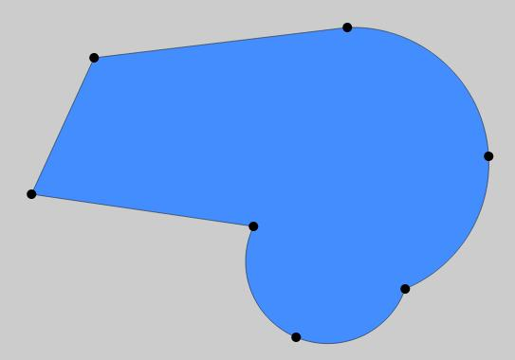
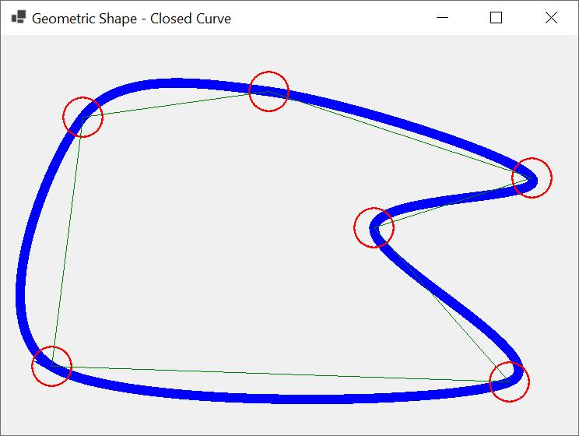
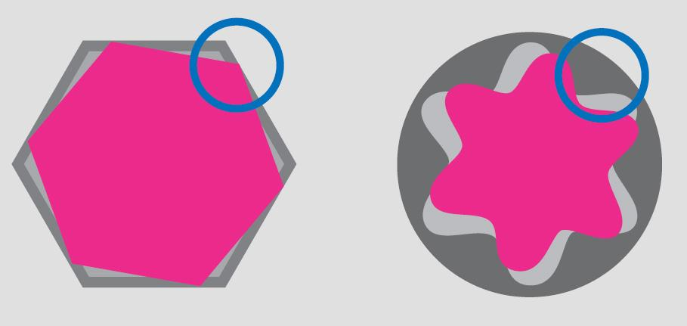

Definition
# Source: AI Source: Provided by: [Data Path: Persons Table -> ID Column: 1, Name_En Column: Motasem Essam] -> From: [ChatGPT] on [7/25/2026]
A Polygon–Circular–Freeform Closed Shape is a closed mixed shape whose boundary contains three different geometric components:
- Polygonal straight segments
- Circular arcs or circular portions
- Freeform curved portions
$$\boxed{\text{Polygon–Circular–Freeform Closed }\text{ShapePolygonal}+\text{Circular}+\text{Freeform}+\text{Closed}}$$
This is therefore a three-component mixed shape.

Characteristics
# Source: AI Source: Provided by: [Data Path: Persons Table -> ID Column: 1, Name_En Column: Motasem Essam] -> From: [ChatGPT] on [7/25/2026]
A Polygon–Circular–Freeform Closed Shape:
- Is completely closed.
- Encloses a bounded region.
- Contains at least one straight-line segment.
- Contains at least one circular arc.
- Contains at least one freeform curved segment.
- May be convex or concave.
- May be symmetric or asymmetric.
- May be regular-looking or irregular.
- Can combine precise geometric elements with freely designed curves.

Types

1. Triangle–Circular–Freeform Closed Shapes
# Source: AI Source: Provided by: [Data Path: Persons Table -> ID Column: 1, Name_En Column: Motasem Essam] -> From: [ChatGPT] on [7/25/2026]
A triangular component is combined with a circular arc and a freeform curve.
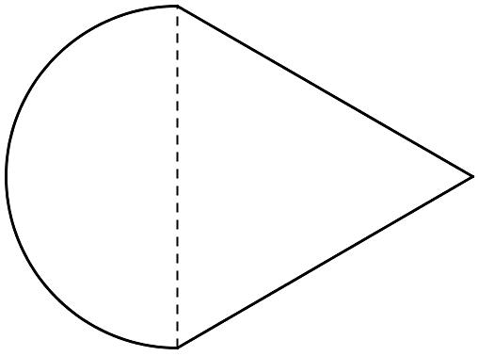
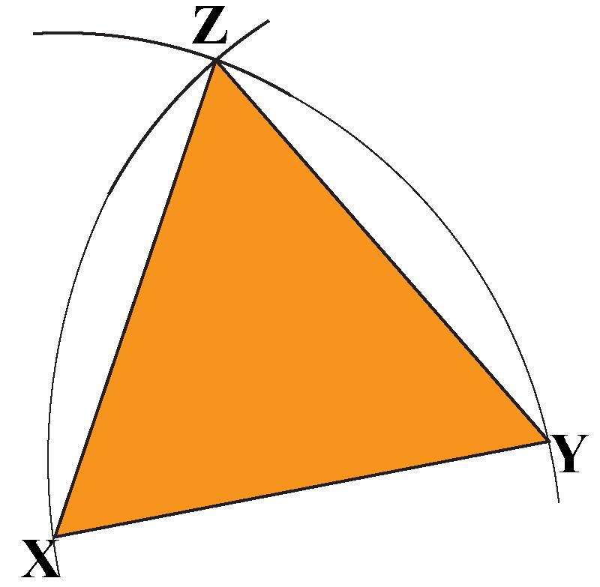
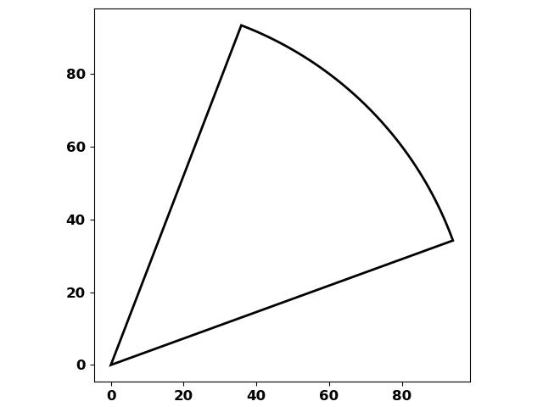
$$\boxed{\text{Triangle}+\text{Circular Arc}+\text{Freeform Curve}}$$

2. Quadrilateral–Circular–Freeform Closed Shapes
# Source: AI Source: Provided by: [Data Path: Persons Table -> ID Column: 1, Name_En Column: Motasem Essam] -> From: [ChatGPT] on [7/25/2026]
A quadrilateral contributes straight sides, while circular and freeform curves complete the boundary.
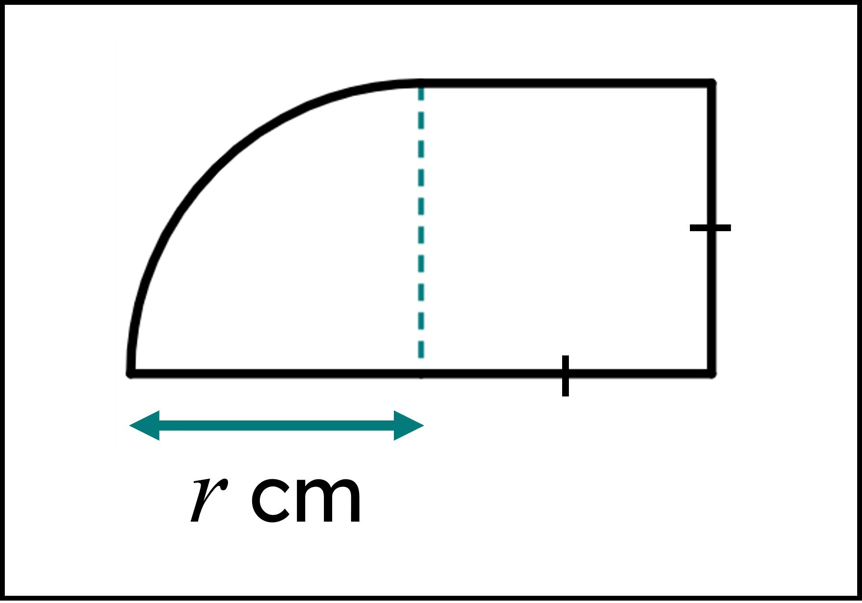
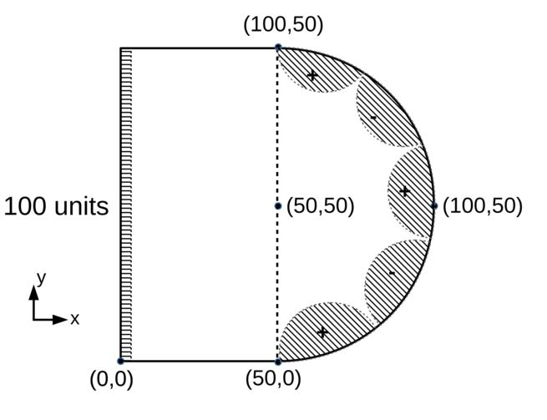
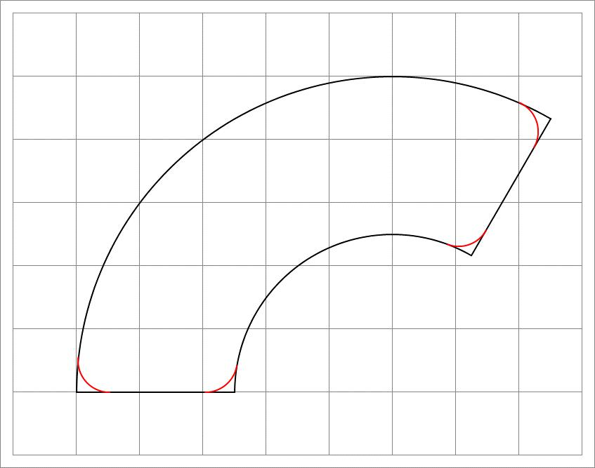
A rectangle is a common starting component.

3. Pentagon–Circular–Freeform Closed Shapes
# Source: AI Source: Provided by: [Data Path: Persons Table -> ID Column: 1, Name_En Column: Motasem Essam] -> From: [ChatGPT] on [7/25/2026]
A pentagonal component is combined with circular and freeform portions.
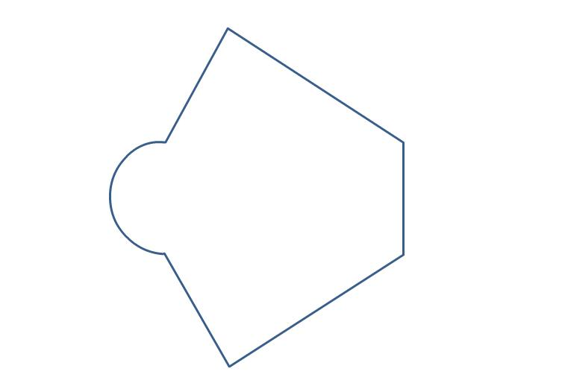
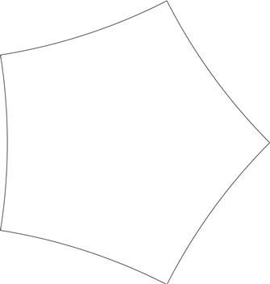

4. Hexagon–Circular–Freeform Closed Shapes
# Source: AI Source: Provided by: [Data Path: Persons Table -> ID Column: 1, Name_En Column: Motasem Essam] -> From: [ChatGPT] on [7/25/2026]
A hexagonal component is combined with one or more circular arcs and freely designed curves.
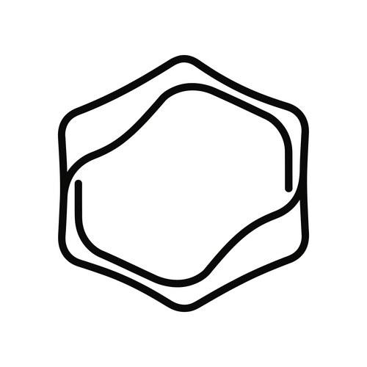
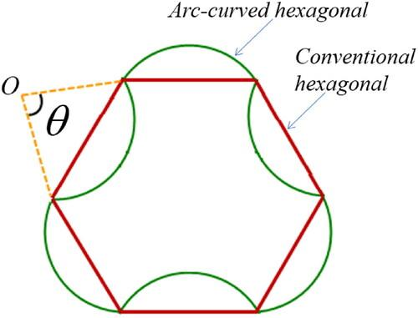

5. Polygon–Circular Arc–Freeform Closed Shapes
# Source: AI Source: Provided by: [Data Path: Persons Table -> ID Column: 1, Name_En Column: Motasem Essam] -> From: [ChatGPT] on [7/25/2026]
A polygon is connected to a circular arc and then to one or more freeform curves.
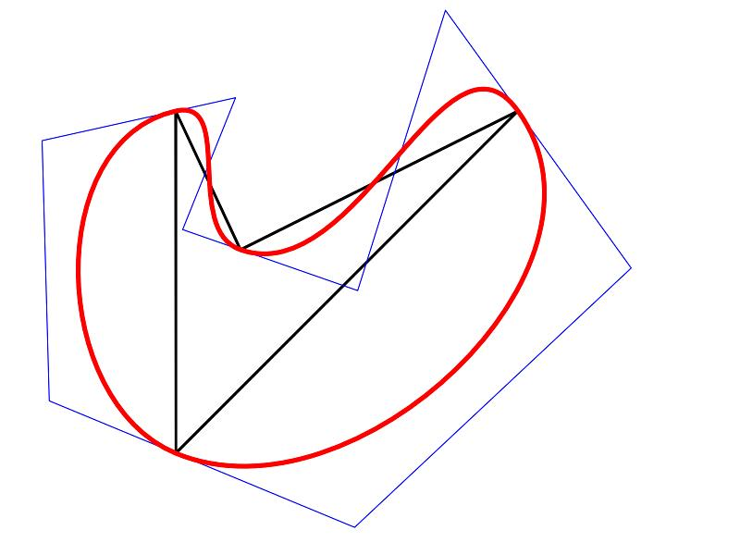
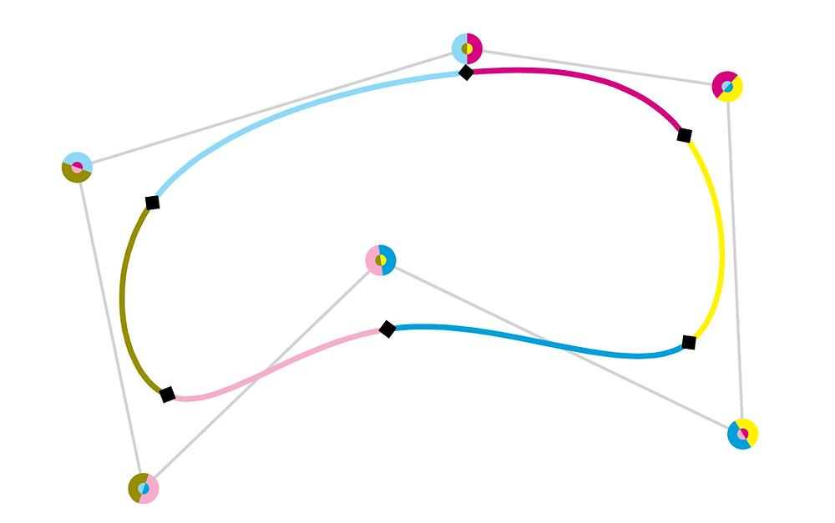
This is the most direct representation of the three-component classification.

6. Polygon–Semicircular–Freeform Closed Shapes
# Source: AI Source: Provided by: [Data Path: Persons Table -> ID Column: 1, Name_En Column: Motasem Essam] -> From: [ChatGPT] on [7/25/2026]
A semicircle forms one part of the boundary while a polygon and freeform curve form the remaining boundary.
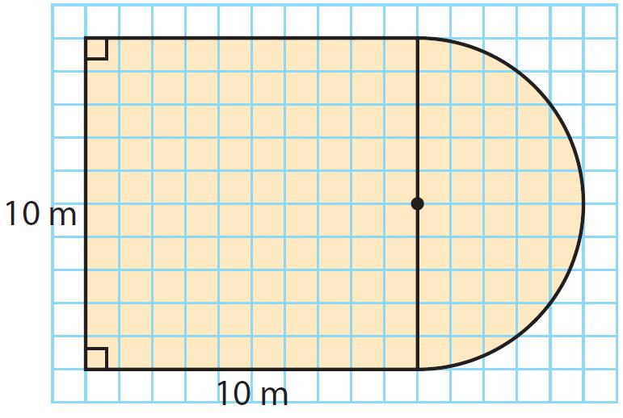
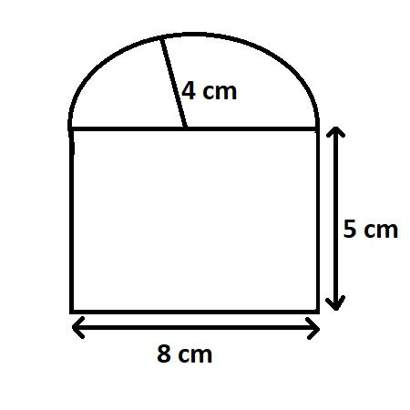

7. Polygon–Rounded Corner–Freeform Closed Shapes
# Source: AI Source: Provided by: [Data Path: Persons Table -> ID Column: 1, Name_En Column: Motasem Essam] -> From: [ChatGPT] on [7/25/2026]
Some polygonal corners are replaced with circular arcs, while another portion uses a freeform curve.
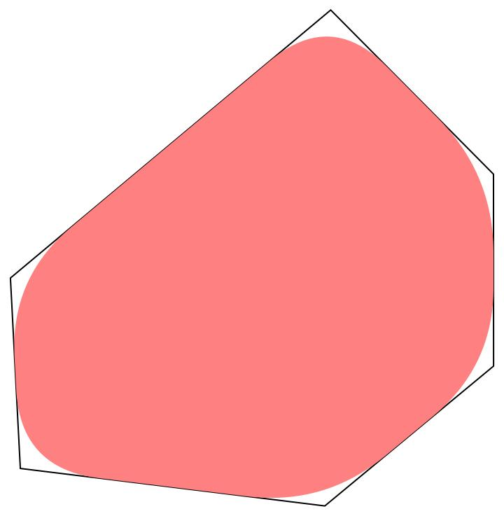
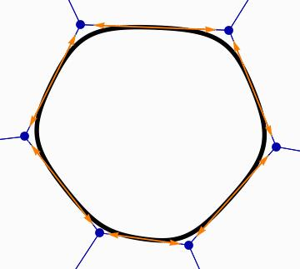
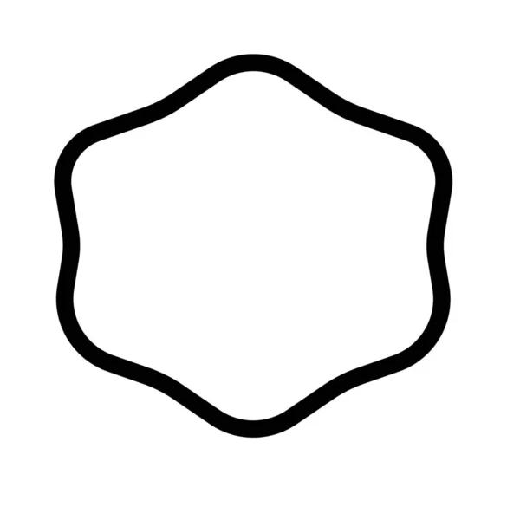
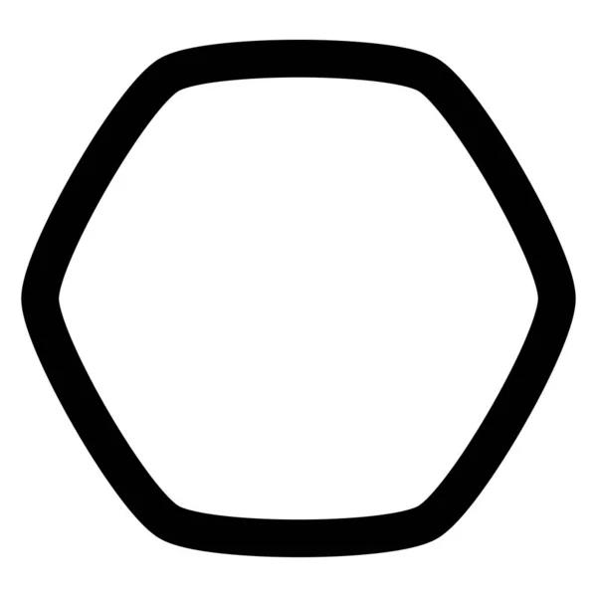
This creates a combination of:
$$\boxed{\text{Straight Segments}+\text{Circular Arcs}+\text{Freeform Curves}}$$

8. Polygon–Circular–Wavy Freeform Closed Shapes
# Source: AI Source: Provided by: [Data Path: Persons Table -> ID Column: 1, Name_En Column: Motasem Essam] -> From: [ChatGPT] on [7/25/2026]
The freeform portion contains irregular waves or undulations.
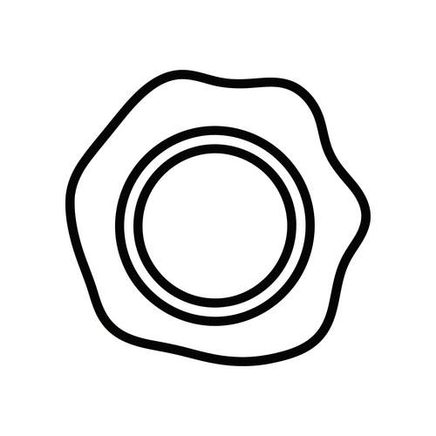
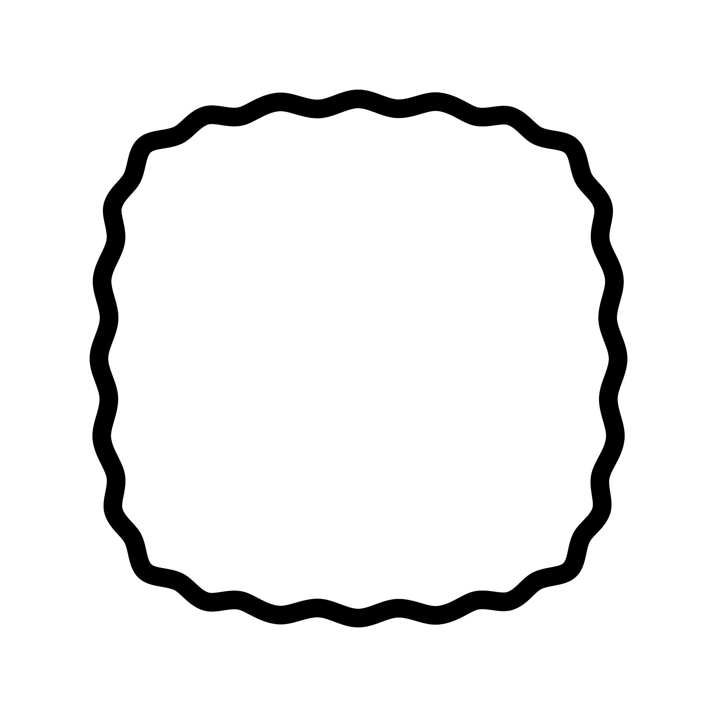
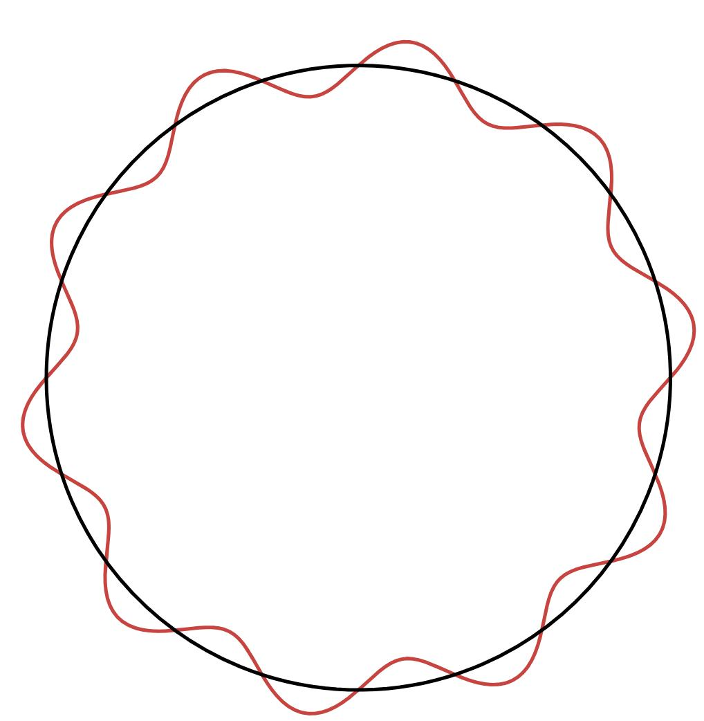
The wavy portion can have variable:
- Amplitude.
- Spacing.
- Curvature.
- Wave count.

9. Asymmetric Polygon–Circular–Freeform Closed Shapes
# Source: AI Source: Provided by: [Data Path: Persons Table -> ID Column: 1, Name_En Column: Motasem Essam] -> From: [ChatGPT] on [7/25/2026]
The three components are arranged without regular symmetry.
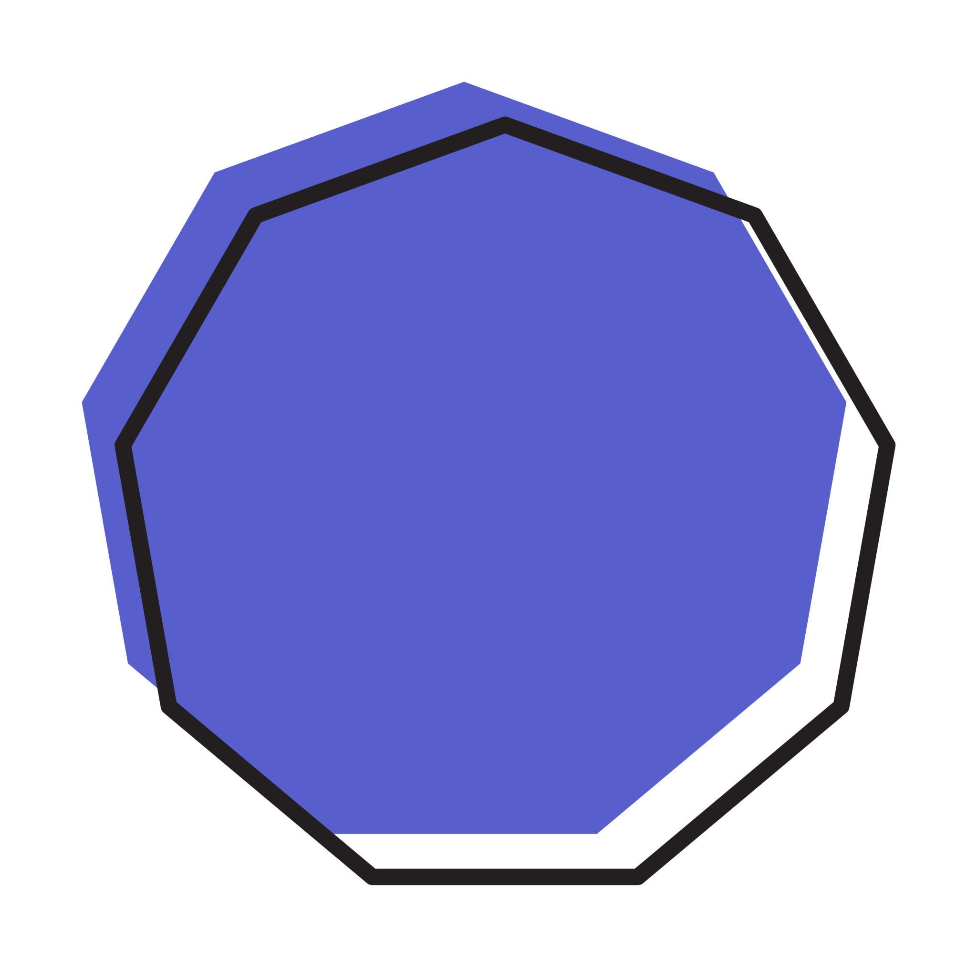
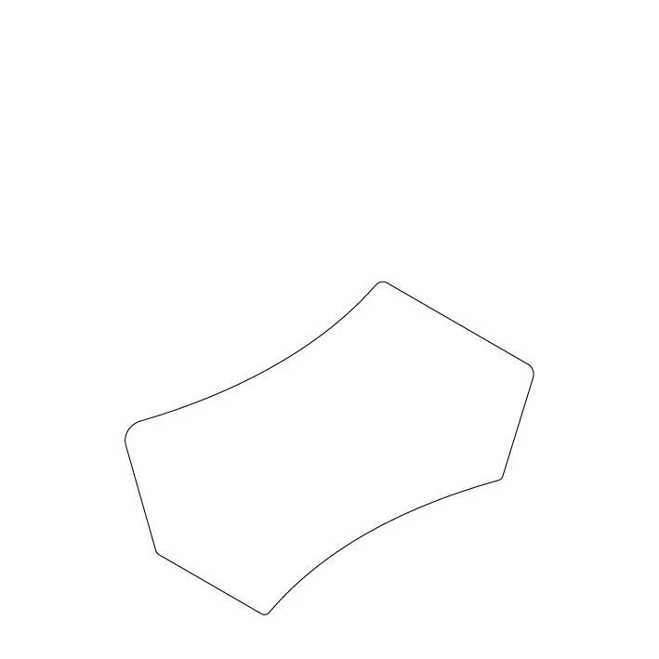
This type can have:
- Unequal polygonal segments.
- Unequal circular arcs.
- Variable freeform curvature.
- Different bulges and indentations.

10. Symmetric Polygon–Circular–Freeform Closed Shapes
# Source: AI Source: Provided by: [Data Path: Persons Table -> ID Column: 1, Name_En Column: Motasem Essam] -> From: [ChatGPT] on [7/25/2026]
The components are arranged so that the complete shape retains one or more symmetry properties.
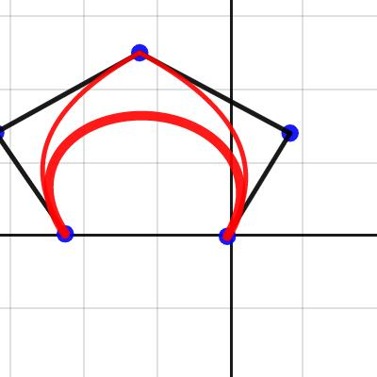
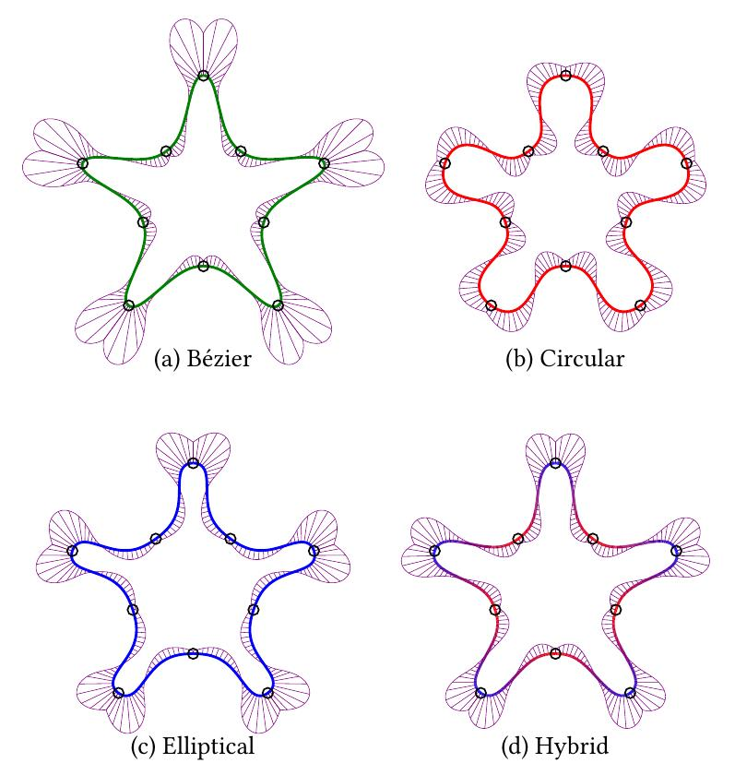
The freeform portion can still be individually irregular while the overall shape is symmetric.

Polygon–Circular–Freeform vs. Other Closed Mixed Shapes
# Source: AI Source: Provided by: [Data Path: Persons Table -> ID Column: 1, Name_En Column: Motasem Essam] -> From: [ChatGPT] on [7/25/2026]
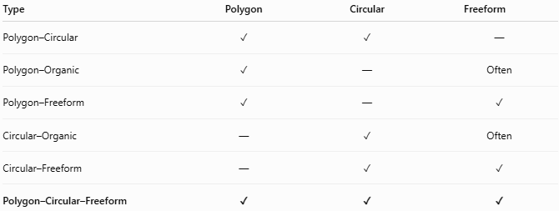
Type | Polygon | Circular | Freeform
Polygon–Circular | ✓ | ✓ | —
Polygon–Organic | ✓ | — | Often
Polygon–Freeform | ✓ | — | ✓
Circular–Organic | — | ✓ | Often
Circular–Freeform | — | ✓ | ✓
Polygon–Circular–Freeform | ✓ | ✓ | ✓
The important distinction is that all three components are required for this category.
$$\boxed{P+C+F}$$
where:
- $P$ = polygonal component
- $C$ = circular component
- $F$ = freeform component

Example of Boundary Classification
# Source: AI Source: Provided by: [Data Path: Persons Table -> ID Column: 1, Name_En Column: Motasem Essam] -> From: [ChatGPT] on [7/25/2026]
Suppose a closed boundary contains:
- Two straight sides.
- One circular arc.
- One Bézier curve.
Then:
$$\boxed{\text{Polygon–Circular–Freeform Closed Shape}}$$
because all three boundary types are present.
By contrast:
Straight + circular only
$$→\text{Polygon–Circular Closed Shape}$$
Circular + freeform only
$$→\text{Circular–Freeform Closed Shape}$$
Straight + freeform only
$$→\text{Polygon–Freeform Closed Shape}$$

Area
# Source: AI Source: Provided by: [Data Path: Persons Table -> ID Column: 1, Name_En Column: Motasem Essam] -> From: [ChatGPT] on [7/25/2026]
The shape can be treated as a composite region:
$$\boxed{A_{\text{total}}=A_{\text{polygon}}±A_{\text{circular}}±A_{\text{freeform}}}$$
The circular component may use standard formulas such as:
$$A_{\text{circle}}=πr^{2}$$
or, for a sector:
$$A_{\text{sector}}=\frac{1}{2}r^{2}θ$$
The freeform portion generally requires numerical integration or computational geometry.

Perimeter
# Source: AI Source: Provided by: [Data Path: Persons Table -> ID Column: 1, Name_En Column: Motasem Essam] -> From: [ChatGPT] on [7/25/2026]
The perimeter combines three types of boundary length:
$$\boxed{P=L_{\text{straight}}+L_{\text{circular}}+L_{\text{freeform}}}$$
For a circular arc:
$$L_{\text{arc}}=rθ$$
For the freeform portion, an arc-length calculation or numerical measurement may be required.

Key Points
# Source: AI Source: Provided by: [Data Path: Persons Table -> ID Column: 1, Name_En Column: Motasem Essam] -> From: [ChatGPT] on [7/25/2026]
A Polygon–Circular–Freeform Closed Shape is:
$$\boxed{\text{Closed}+\text{Polygonal}+\text{Circular}+\text{Freeform}}$$
It contains three distinct boundary types:
- Straight polygonal segments
- Circular arcs
- Freely controlled curves

Conclusion
# Source: AI Source: Provided by: [Data Path: Persons Table -> ID Column: 1, Name_En Column: Motasem Essam] -> From: [ChatGPT] on [7/25/2026]
Polygon–Circular–Freeform Closed Shapes are among the more complex closed mixed shapes, because they combine polygonal geometry, circular geometry, and freeform curvature in a single closed boundary. They can be further classified by the polygon type, circular component, freeform pattern, and symmetry. This makes the category useful for describing composite geometric forms that cannot be classified as purely polygonal, purely circular, or purely freeform.

